**SALES PREDICTION DATASET**

* **Sharon Blessy J V**

1. **What is the average amount spent on TV advertising in the dataset?**

**Ans.**

***Code Snippet:***

**tv_amt_avg = sd['TV'].mean()**

**print("Average amount spent on TV advertising: Rs.", tv_amt_avg)**

***Output:***



1. **What is the correlation between radio advertising expenditure and product sales?**

**Ans.**

***Code Snippet:***

**corr_radio = sd['Radio'].corr(sd['Sales'])**

**print("Correlation between radio advertising expenditure and product sales: ", corr_radio)**

***Output:***

This indicates a weak positive relationship(correlation).

1. **Which advertising medium has the highest impact on sales based on the dataset?**

**Ans.**

***Code Snippet:***

**corr_tv = sd['TV'].corr(sd['Sales'])**

**corr_radio = sd['Radio'].corr(sd['Sales'])**

**corr_newspaper = sd['Newspaper'].corr(sd['Sales'])**

**if corr_tv > corr_radio and corr_tv > corr_newspaper:**

**print("TV advertising has the highest impact on sales.")**

**elif corr_radio > corr_tv and corr_radio > corr_newspaper:**

**print("Radio advertising has the highest impact on sales.")**

**else:**

**print("Newspaper advertising has the highest impact on sales.")**

***Output:***

1. **Plot a linear regression line that includes all variables (TV, Radio, Newspaper) to predict Sales, and visualize the model's predictions against the actual sales values.**

**Ans.**

***Code Snippet:***

**from sklearn.model_selection import train_test_split**

**from sklearn.linear_model import LinearRegression**

**from sklearn.metrics import mean_squared_error, r2_score**

**from sklearn.impute import SimpleImputer**

**X = sd[['TV', 'Radio', 'Newspaper']]**

**y = sd['Sales']**

**imputer = SimpleImputer(strategy='mean')**

**X = imputer.fit_transform(X)**

**# Split the data**

**X_train, X_test, y_train, y_test = train_test_split(X, y, test_size=0.2, random_state=42)**

**# Initialize and train the model**

**model = LinearRegression()**

**model.fit(X_train, y_train)**

**y_pred = model.predict(X_test)**

**# Plotting actual vs predicted sales**

**plt.figure(figsize=(12, 6))**

**# Plot predicted vs actual sales**

**plt.subplot(1, 2, 1)**

**plt.scatter(y_test, y_pred, color='blue', alpha=0.5)**

**plt.plot([y_test.min(), y_test.max()], [y_test.min(), y_test.max()], color='red', linestyle='--')**

**plt.xlabel('Actual Sales')**

**plt.ylabel('Predicted Sales')**

**plt.title('Actual vs Predicted Sales')**

**# Plot residuals**

**plt.subplot(1, 2, 2)**

**residuals = y_test - y_pred**

**sns.histplot(residuals, kde=True, color='blue')**

**plt.xlabel('Residuals')**

**plt.title('Distribution of Residuals')**

**plt.tight_layout()**

**plt.show()**

**# Print evaluation metrics**

**mse = mean_squared_error(y_test, y_pred)**

**r2 = r2_score(y_test, y_pred)**

**print(f"Mean Squared Error: {mse}")**

**print(f"R^2 Score: {r2}")**

***Output:*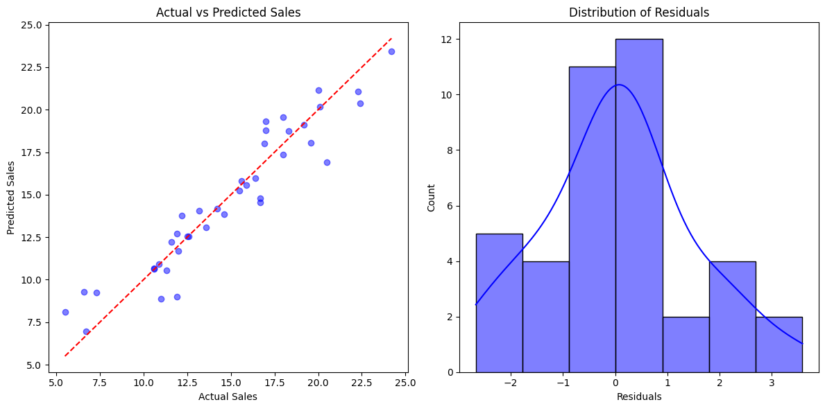**



1. **How would sales be predicted for a new set of advertising expenditures: $200 on TV, $40 on Radio, and $50 on Newspaper?**

**Ans.**

***Code Snippet:***

**X = sd[['TV', 'Radio', 'Newspaper']]**

**y = sd['Sales']**

**imputer = SimpleImputer(strategy='mean')**

**X = imputer.fit_transform(X)**

**# Splitting data into training and testing sets**

**X_train, X_test, y_train, y_test = train_test_split(X, y, test_size=0.2, random_state=42)**

**# Fit the linear regression model**

**model = LinearRegression()**

**model.fit(X_train, y_train)**

**# TV: $200, Radio: $40, Newspaper: $50**

**new_ad_expenditures = [[200, 40, 50]]**

**# prediction for new values**

**predicted_sales = model.predict(new_ad_expenditures)**

**print(f"Predicted Sales for $200 on TV, $40 on Radio, and $50 on Newspaper: {predicted_sales[0]:.2f}")**

***Output:***

1. **How does the performance of the linear regression model change when the dataset is normalized?**

**Ans.**

***Code Snippet:***

**X = sd[['TV', 'Radio', 'Newspaper']]**

**y = sd['Sales']**

**# Split the data into training and testing sets (80% train, 20% test)**

**X_train, X_test, y_train, y_test = train_test_split(X, y, test_size=0.2, random_state=42)**

**imputer = SimpleImputer(strategy='mean')**

**X_train = imputer.fit_transform(X_train)**

**X_test = imputer.transform(X_test)**

**# Train the model on the unnormalized data**

**model = LinearRegression()**

**model.fit(X_train, y_train)**

**y_pred = model.predict(X_test)**

**mse_unnormalized = mean_squared_error(y_test, y_pred)**

**r2_unnormalized = r2_score(y_test, y_pred)**

**print(f"Unnormalized Data - MSE: {mse_unnormalized:.2f}, R²: {r2_unnormalized:.2f}")**

**# Normalize the feature data using StandardScaler**

**from sklearn.preprocessing import StandardScaler #Import the StandardScaler module**

**scaler = StandardScaler()**

**X_train_scaled = scaler.fit_transform(X_train)**

**X_test_scaled = scaler.transform(X_test)**

**# Train the model on the normalized data**

**model_normalized = LinearRegression()**

**model_normalized.fit(X_train_scaled, y_train)**

**y_pred_scaled = model_normalized.predict(X_test_scaled)**

**# Performance on the normalized data**

**mse_normalized = mean_squared_error(y_test, y_pred_scaled)**

**r2_normalized = r2_score(y_test, y_pred_scaled)**

**print(f"Normalized Data - MSE: {mse_normalized:.2f}, R²: {r2_normalized:.2f}")**

***Output:***



1. **What is the impact on the sales prediction when only radio and newspaper advertising expenditures are used as predictors?**

**Ans.**

***Output:***

**X = sd[['TV', 'Radio', 'Newspaper']]**

**y = sd['Sales']**

**X_train_all, X_test_all, y_train, y_test = train_test_split(X, y, test_size=0.2, random_state=42)**

**imputer = SimpleImputer(strategy='mean')**

**X_train_all = imputer.fit_transform(X_train_all)**

**X_test_all = imputer.transform(X_test_all)**

**model_all = LinearRegression()**

**model_all.fit(X_train_all, y_train)**

**y_pred_all = model_all.predict(X_test_all)**

**mse_all = mean_squared_error(y_test, y_pred_all)**

**r2_all = r2_score(y_test, y_pred_all)**

**print(f"Model with TV, Radio, and Newspaper - MSE: {mse_all:.2f}, R²: {r2_all:.2f}")**

**X_radio_newspaper = sd[['Radio', 'Newspaper']]**

**X_train_rn, X_test_rn, y_train_rn, y_test_rn = train_test_split(X_radio_newspaper, y, test_size=0.2, random_state=42)**

**# Apply the imputer to X_train_rn and X_test_rn**

**X_train_rn = imputer.fit_transform(X_train_rn)**

**X_test_rn = imputer.transform(X_test_rn)**

**model_rn = LinearRegression()**

**model_rn.fit(X_train_rn, y_train_rn)**

**y_pred_rn = model_rn.predict(X_test_rn)**

**mse_rn = mean_squared_error(y_test_rn, y_pred_rn)**

**r2_rn = r2_score(y_test_rn, y_pred_rn)**

**print(f"Model with Radio and Newspaper - MSE: {mse_rn:.2f}, R²: {r2_rn:.2f}")**

***Output:***